# *Web Programming I (420-C10-HR)*

# *Lab 4 – CSS Introduction*

Date assigned: Tuesday, September 15, 2015

Date due: **Tuesday, September 15, 2015, End of your lab period**

**Learning Objectives**

Upon successful completion of this lab exercise, the student will be able to:

* Start off the Case Study we will be using for the year
* Create web pages using inline and embedded CSS

To do:

**Lab Set-Up**

1. Download the C10_L04 folder from the Moodle page. Extract (unzip) the folder to your H:\420-C10\Labs folder. Rename the folder to **YourUserName_C10_L04**.
2. You do not have to do the sections marked as BONUS MARKS. If you do they will be marked and marks will be added to your mark on the lab up to a total of 100%. Anything beyond 100% will be rewarded in some other way. If you do not do the bonuses you will not lose any marks. **IMPORTANT**: Do NOT attempt the bonus marks until AFTER YOU COMPLETE THE REGULAR STEPS OF THE LAB.

**Part A – Fish Creek Animal Hospital Case Study**

We will be working with one or two of the case studies from your textbook throughout the course. Complete the tasks in the Fish Creek Animal Hospital case study on pages 69 – 72 of your textbook. Check the following notes:

* The site must be HTML5 compliant;
* In Task 1, when they tell you to create a new folder on your flash drive, create the folder (called fishcreek) in the folder you created at the beginning of the lab (**YourUserName_C10_L04**) in your H:\420-C10\Labs folder.
* In Task 2, step 3 use RELATIVE hyperlinks.

NOTE: You do not have to guess at any of the steps. The steps are listed for you in the case study and you simply have to follow the steps as they are listed.

**Part B – CSS Introduction**

1. In this exercise you use inline styles to format a Web page for a relocation service. The file to which you will add the style information, Relocation.html, is in the folder you copied at the beginning of the lab. The final page should look like this:

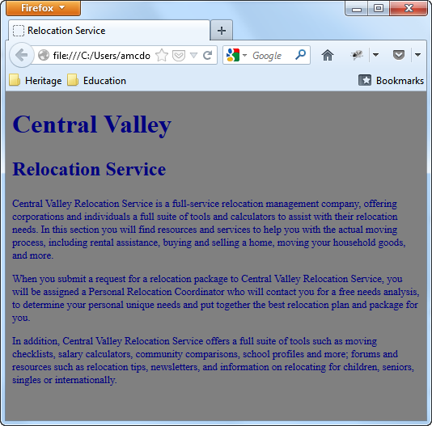

Steps:

* 1. Open Relocation.html in Notepad++ or Notepad. The document body contains two heading elements and three paragraph elements.
  2. To the <body> element, add the following inline style declaration to change the background colour of the page to grey



* 1. Next, modify the two heading elements so they contain inline style formatting as follows:

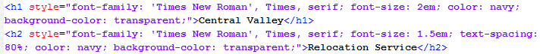

* 1. Add the following inline style declaration to each paragraph element:



* 1. Save the file and check it in a browser. It should look like the picture above.

1. In this exercise, you use an internal style sheet to add style information to a Web page that contains customer testimonials for an auto body shop. The file you need, AutoBodyShop.html, is in the folder you copied at the beginning of the lab. Make sure you look at the file in the browser before you add the embedded CSS and then again afterwards. The final page should look like this:

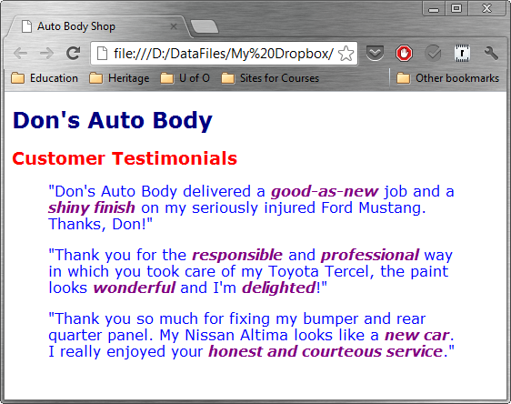

* 1. Open AutoBodyShop.html in Notepad++ or Notepad. The document body contains three <blockquote> elements each of which includes text and <em> elements.
  2. Add the following internal style sheet above the closing </head> element. The style sheet includes declarations for h1, h2 and blockquote selectors, along with a contextual selector for the <em> element when located within a <div> element.

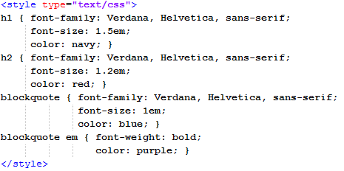

* 1. Save, close and test the file in a browser. If it does not look like the file above, try again.

**Part B – Summoner’s Rift Weapons**

Note: For this section you may need to look ahead in your notes or in your book or on the Internet to get the property declarations you will need for some of the CSS you will be creating. I give you the property name the first time it is used. You should be able to get the rest at that point.

I strongly suggest that you save the file at the end of each step and test it out in the browser before moving on to the next step.

1. Open Notepad++ (or Notepad), by selecting Start, All Programs, Accessories, Notepad.
   1. **Open** the league.html file that you copied at the beginning of the lab. You may want to look at the file in the browser as it currently is. A picture of the final product can be found at the end of the lab.
2. Use **embedded** CSS to make the following changes to the file.
   1. Make the background colour (background-color) of the page (that is, the body) #999966 and the text colour (color) #000033
   2. For the main heading (h1) on the page:
      1. Align to the centre of the page (text-align);
      2. Use the inverse of the default colouring (background colour #000033 and text colour #999966);
      3. Has a line height (line-height) of 200%;
      4. Uses the Verdana, Arial or sans-serif font family (in that order) (font-family).
   3. The default paragraph font size (font-size) is reduced to 90% of the normal size, using relative sizing techniques and the em value type.
   4. All heading 2 (h2) elements:
      1. Come from the font family “Comic Sans MS” or sans-serif;  
         Note: the quotes around the font family is required
      2. Are bold (font-weight);
      3. Are in italics (font-style).
      4. Have a line height of 150%
   5. The items in the “About Us Products Clients Endorsements” are split into 4 separate hyperlinks (<a> (anchor) element) each spaced exactly 4 spaces apart (hint, think about non-breakable spaces and use the anchor tag with an href=“#”).
   6. The hyperlinks:
      1. Have no text decoration (text-decoration);
      2. Has text coloured black (#000000)
      3. **For bonus marks**: When the person hovers over the link with the mouse, change the text color to white (#FFFFFF).
   7. All the third level header (h3) elements are:
      1. Aligned right (text-align)
      2. In italics;
      3. In the font family: Verdana, Arial or sans serif
   8. All unordered list items are of regular relative font size using the em value (1).
   9. Use **inline** CSS to change the line immediately after the first header (We’re in a Different League) to be:
      1. Aligned to the centre;
      2. Font style is italics;
      3. In the font family: Verdana, Arial or sans serif;
      4. Have a font size 80% of a capital letter M (em)
   10. Use **inline** CSS so that the paragraphs in the Endorsements section (and only the endorsement paragraphs) have:
       1. A font size of 125%;
       2. Are in italics
       3. A line height of 125%
   11. Use inline CSS so that the Copyright line (last line) is:
       1. Aligned centre
       2. Of size .5 of the capital em
       3. Text is coloured #003333
       4. Is in the font family Verdana, Arial, sans-serif
       5. **For bonus marks**: use an id called copydiv so instead of using inline CSS.
3. Change the list of clients to be an unordered list.
4. Add spacing and indentation to the HTML file to make the file easier to read.
5. Validate the HTML at the same site as used in the last lab (<http://validator.w3.org/>). Correct any errors. Yes, I DID put tags and elements in the code incorrectly on purpose.
6. The final page should look like the image on the last page of this document or the image file league_solution.html.png in the YourUserName_C10_L04 that you copied at the beginning of this lab.
7. Save the file in the YourUserName_C10_L04 folder in your Lab folder on your home drive that you created at the beginning of this lab.

**Part C – Petting Zoo**

In this exercise you create a Web page for a petting zoo that uses an embedded style sheet

1. Open up the html5 document template from last week’s lab in Notepad++ and save it as PettingZoo.html in the folder for this week.
2. Create the document that is shown in the following diagram.
   1. Add a title to the document
   2. Add an embedded style sheet with the following properties for the following elements:
      1. First level headers are coloured navy (color) with a transparent background (background-color), a font-size twice the size of a capital M (em) and the text is aligned (text-align) to the centre of the page;
      2. Second level headers are coloured maroon with a transparent background, a font size 1.5 times the size of a capital M and the text is aligned to the centre of the page;
      3. The next two paragraphs both have a font family of Verdana, Arial or sans-serif, a line height of 150%, a font size of 80% and the text is indented (text-indent) 5%
      4. The final footer has its own div and inside the div there is a paragraph with a font-family of Verdana, Arial, sans-serif, a line height of 150%, a font size of 60% and the text is aligned to the centre and bolded.
   3. The final web page should look like the one pictured here:

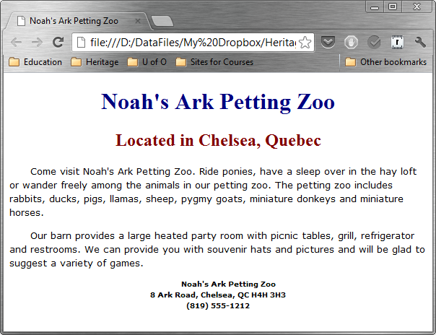

**To submit**

When you have completed the lab exercise, zip the folder containing all the files and hand it into Moodle using the appropriate techniques.

